# Boolean Operators in Python: and, or, not

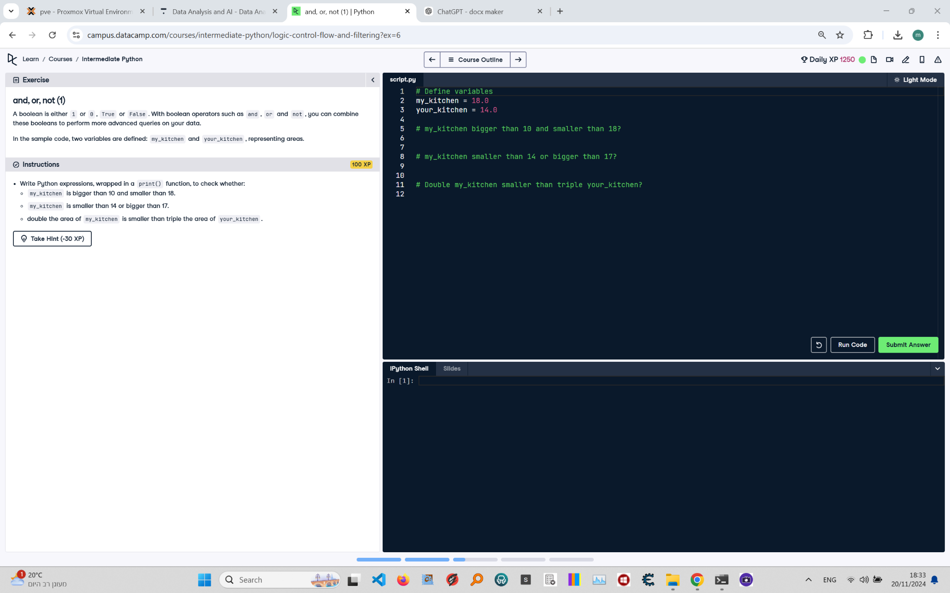

**Question:**

Write Python expressions, wrapped in a `print()` function, to check whether:  
1. `my_kitchen` is bigger than 10 and smaller than 18.  
2. `my_kitchen` is smaller than 14 or bigger than 17.  
3. Double the area of `my_kitchen` is smaller than triple the area of `your_kitchen`.

**Answer:**

Here is the Python code that solves the problem:

# Define variables  
my_kitchen = 18.0  
your_kitchen = 14.0  
  
# my_kitchen bigger than 10 and smaller than 18  
print(my_kitchen > 10 and my_kitchen < 18)  
  
# my_kitchen smaller than 14 or bigger than 17  
print(my_kitchen < 14 or my_kitchen > 17)  
  
# Double my_kitchen smaller than triple your_kitchen  
print((my_kitchen * 2) < (your_kitchen * 3))

**Explanation of the Code:**

1. **Define variables**: `my_kitchen` and `your_kitchen` represent the areas of two kitchens.  
2. **Logical AND operation**: The first print statement uses `and` to check if `my_kitchen` is greater than 10 and less than 18, returning `True` only if both conditions are satisfied.  
3. **Logical OR operation**: The second print statement uses `or` to check if `my_kitchen` is less than 14 or greater than 17, returning `True` if at least one of the conditions is satisfied.  
4. **Arithmetic and comparison operation**: The third print statement multiplies `my_kitchen` by 2 and `your_kitchen` by 3, then compares them to check if the double of `my_kitchen` is smaller than the triple of `your_kitchen`, returning the result as `True` or `False`.